Physical Science Chapter 20- Mixtures and Solutions
Mixtures
All matter is either a pure substance or a mixture
Most of the ‘stuff’ in the world is in the form of a mixture
(See ‘Matter Map’- Ch. 19)
- Properties of Mixtures
  - The particles of mixtures are physically placed together, not chemically combined; therefore, they can be separated by physical means
  - Mixtures can be made in any proportion
  - All the parts of a mixture retain their own properties
- Phases of Mixtures and Description
  - Gel
    - A solid dispersed in a liquid
    - Ex: Jell-O
  - Sol
    - A solid-in- liquid that is more ‘liquidy’
    - Ex: Paints and Inks
  - Emulsion
    - Contain two or more phases in the liquid state
    - The liquids will not mix (immiscible)
    - Sometimes a liquid is made of such small particles that the particles cannot be seen
    - Over time the liquids will separate
    - Homogenization- a thorough mixing process that slows separation
    - Ex: cream cheese, milk, mayonnaise, butter
  - Foam
    - A gas dispersed in a liquid
    - Ex: Whipped cream, shaving cream
  - Aerosol
    - A solid or liquid dispersed in a gas
    - Ex: Water or dust in the air, hairspray
  - Heterogeneous Alloys
    - A solid-solid mixture that is usually metal
    - Ex: fuel plates in nuclear reactors
- Classifying Mixtures by Phase
  - A homogeneous mixture has only one phase
    - Another word for this is ‘solution’
  - A heterogeneous mixture has distinct phases
    - If only the word ‘mixture’ is used, it is understood to be heterogeneous
  - Continuous Phase- An unbroken phase in which the other phases are mixed
  - Dispersed Phase- Scattered throughout a continuous phase
- Classifying Mixtures by Particle Size
  - Colloidal Dispersion
    - A colloidal dispersion consists of particles too small to see
    - Therefore, a dispersion can look like a homogeneous mixture
    - The dispersed particles are called colloids
    - Thermal vibrations of the continuous phase particles keep the dispersed phase mixed
    - Many gels, sols, emulsions, foams, and aerosols are colloidal dispersions
  - Suspensions
    - Particles are larger than colloid particles and will eventually settle out
Solutions
- Defining Solutions
  - Solutions are liquid most of the time
  - Solutions have the tiniest particles of types of mixtures
  - Particles in colloidal dispersions and/or suspensions are large enough to scatter light
    - This scattering is called the Tyndall Effect
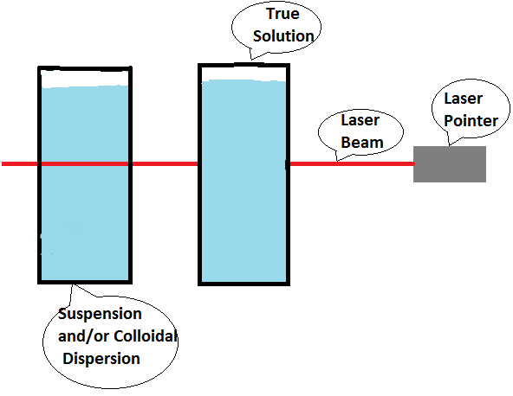
  - Particles dissolved in a solution are too small and do not scatter the light
- Homogeneous Mixtures
  - Homogeneous mixtures are uniform mixtures with a single phase, but two substances are involved
  - The SOLUTE is the substance being dissolved
  - The SOLVENT is the substance doing the dissolving
  - There is always less solute then solvent in the mixture
  - Although the solute is completely mixed in the solution, there is no chemical combination
  - No new substance is formed
- Types of Solution by Solvent
  - Liquid solution
    - Most common
    - SOLUTE: Solids, liquids, and/or gasses
    - Ex: salt + water, sugar + water CO₂ + water
  - Solid Solutions
    - SOLUTE: Solids, liquids, and/or gasses
        - Gas-in-Solid: H₂ into Platinum
        - Liquid-n-Solid: Mercury into gold (Amalgam)
        - Solid-in-Solid: Alloys (Metals mixed in a liquid state and then cooled)
  - Gas solutions
    - SOLUTE: Gasses only
      - Ex: air (Nitrogen and oxygen)
- Water- The Universal Solvent
  - Water is the most common solvent in liquid solutions
  - Often called the ‘Universal Solvent’
  - Such a good solvent, it is nearly impossible to find 100% pure water
  - Its structure (bent 109.5) makes it polar, and thus an effective solvent
  - Because it is polar, water attracts ionic and polar covalent substances
- The Solution Process
  - For an ionic solid to dissolve, the bonds between the ions must be broken
  - This process is called disassociation
  - The specific term for the disassociation of polar covalent or ionic substances is ionization
  - Other water molecules attach to separated ions in a process called hydration
  - If the solvent is not water, the process is called solvation
- The Solubility Rule
LIKE DISSOLVES LIKE!
  - This means that polar covalent substances dissolve polar and ionic solutes, and nonpolar solvents dissolve nonpolar solutes
Solubility
- Solubility Basics
  - A few liquid solutes are infinitely soluble in some liquid solvents
  - This means that they can freely mix in any proportion
  - The term for this property is miscible
    - Ex: Alcohol* and water
*Not all alcohols are miscible
  - The opposite of miscible is immiscible
  - Liquid solutes that cannot mix with liquid solutions are immiscible
  - Most solvents have a limit as to how much solute they can dissolve
  - This limit is called solubility
  - Solubility is stated in grams of solute that can be dissolved into 100mL of water
- Factors Affecting Solubility
  - Two primary factors that affect solubility:
    - Temperature
      - When dissolving liquids in solids, an increase in temperature equals an decrease in solubility (most of the time)
      - When dissolving gasses, an increase in temperature equals a decrease in solubility
    - Pressure
      - When dissolving liquids or solids, pressure has no noticeable effect on solubility
      - When dissolving gasses, an increase in pressure equals an increase in solubility (directly proportional)
Henry’s Law
The solubility of gasses increases with the partial
pressure of the gas above the solution
Saturation
- Defining Saturation
  - When a solute is at the solubility limit, the solution is said to be saturated
  - If less than the maximum amount of solute is dissolved, the solution is unsaturated
  - If a saturated solution is cooled, it can become super-saturated
  - Super-saturated means that the solution has more than the usual maximum amount of solute dissolved
  - If a super-saturated solution is disturbed, the excess solute will quickly fall out of the solution (precipitate)
- Rate of Solution
  - The rate of solution is affected by two factors:
    - Inherent Solubility
    - The number of effective solute-solvent collisions
      - The number of collisions can be changed by:
        - Changing the temperature
        - Stirring
        - Changing the surface area
- Solution Concentration
  - Concentration
    - The measure of the amount of solute that is dissolved
    - Dilute and concentrate are too vague
  - Percentage by Mass
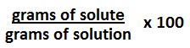
  - Comparing different concentrations of the same solution

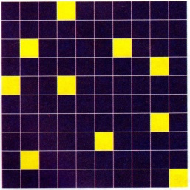
Illustration of percentage by mass. Each block represents a mass unit. There are one hundred blocks. This solution has a concentration of 10% solute (yellow) by mass.
- Molarity
  - Most common measure of concentration
  - The measure of the number of solute particles dissolved rather than the mass of the dissolved particles
  - Because the size of the particles is so small, the number is tremendously large
  - The unit used to measure the number of particles is the mole
  - A mole of solute has 6.022x10²³ particles
    - 6.022x10²³ is called Avogadro’s Number
  - Molarity Formula
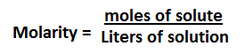
Colligative Properties
- Defining Colligative Properties
  - Colligative properties depend only on the number of solute particles dissolved in the solution
  - Colligative properties affect:
    - Boiling point
    - Freezing point
    - Osmotic Pressure
- Boiling Point Elevation
  - An increase in solute raises the boiling point
  - This is called Boiling Point Elevation
  - The solute interferes with boiling, so the temperature must be increased in order to reach the boiling point
- Freezing Point Depression
  - An increase in solute lowers the freezing point
  - This is called Freezing Point Depression
  - The solute interferes with freezing, so the temperature must be lowered in order to reach the freezing point
- Osmosis
  - Osmosis is the movement of solvent (often water) from an area of high concentration to an area of low concentration through a semi-permeable membrane
  - Water moves from a region of high concentration to a region of low concentration
  - Osmosis can be described as water going from a diluted solution to a concentrated solution
- Osmotic Pressure
  - Osmotic pressure is the amount of pressure required to stop osmosis
- Reverse Osmosis
  - Reverse osmosis also requires a semi-permeable membrane which can be used to separate seawater from freshwater in order to make it drinkable
  - The process of removing salt from seawater is called desalination

Test Info
Date: 11/28/12
Room: 208
Instructor: Mr. Jones
Time: 9:15- 10:00

