Physical Science Chapter 21- Acids, Bases, and Salts
Introduction
Where are acids and bases found in the world around us? Have you ever tasted a food that was sour? bitter? The reason these foods tasted the way they did is because of acids and bases found in the foods. For example, grapes contain tartaric acid; and citrus fruits contain citric acid and ascorbic acid. Bitter foods
like unsweetened chocolate, raw almonds, and various herbs contain bases like ammonium hydroxide, potassium hydroxide, and sodium hydroxide. In this chapter, we will learn more about the chemical structure of acids, bases, and salts.
Acids and Bases
Ionization of Water
When two water molecules collide with each other, if the water is pure water, the result will be two new ions; a hydronium ion (H₃O⁺) and a hydroxide ion (OH⁻). The equation 2H₂O→H₃O⁺+OH⁻ shows the reaction.
- Dynamic Equilibrium
  - The above reaction is constantly occurring in water
  - The constant but equal change is called a Dynamic Equilibrium
  - Dynamic- Changing
Equilibrium- Balanced
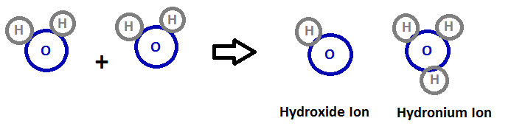
  - The opposite reaction occurs just as easily (just flip the arrow
Defining Acids and Bases
- The Arrhenius Definition
  - Definition of an acid
    - An acid is anything that releases hydrogen ions in a water solution. (A hydrogen ion is the same thing as a proton)
    - Formic Acid (HCHO₂) is an example
  - Definition of a Base
    - A base is a substance that releases hydroxide ions (OH⁻) in a water solution
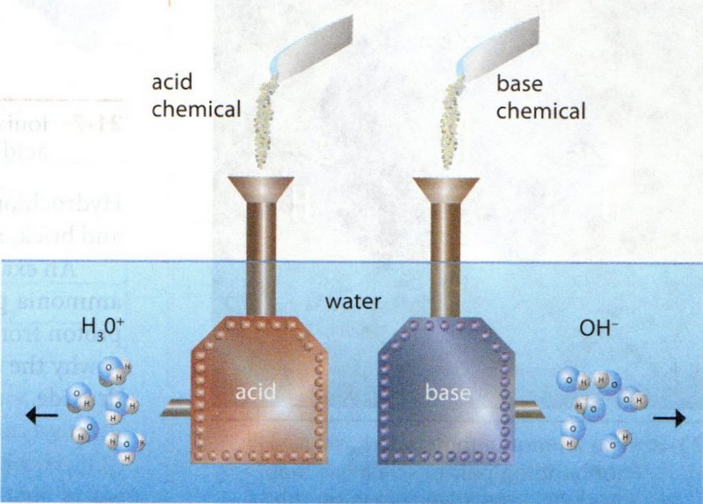
- Brønsted–Lowry
  - Definition of an Acid
    - An acid is any compound that gives a proton (hydrogen ion)
  - Definition of a Base
    - A compound that accepts a proton
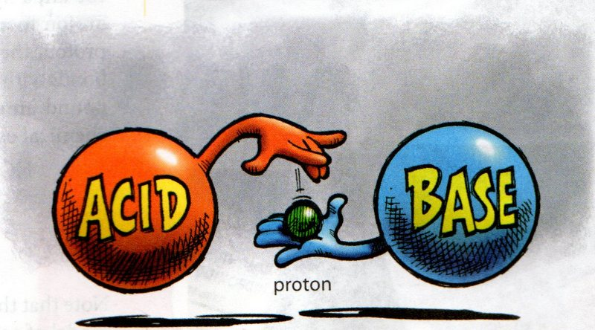
  - Example:
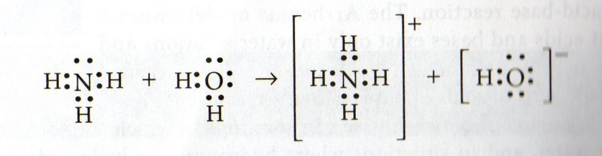
  - Water is not required for a reaction according to the Brønsted–Lowry definition, but is required for Arrhenius
  - Brønsted–Lowry acids and bases always occur in conjugate pairs; this means that if you have an acid, you WILL have a base
How Many Hydrogens?
- Vinegar
  - HC₂H₃O₂
  - Only the 1st hydrogen (red) can be lost
  - The other hydrogens are attached to the carbon
ONLY THE HYDROGENS LISTED ON THE OUTSIDE OF
THE FORMULA ARE IONIZABLE!
Types of Acids
- Three types of acids (Polyprotic acids)
  - Monoprotic acids
    - Lose only 1 Hydrogen
  - Diprotic acids
    - Lose 2 Hydrogens
    - Can be classified as Polyprotic acids
  - Triprotic acids
    - Lose 3 Hydrogens
    - Can be classified as Polyprotic acids
It becomes more difficult to remove Hydrogen ions with each ionization.
Conjugate Acids and Bases
- How Conjugate Acids and Bases are Formed
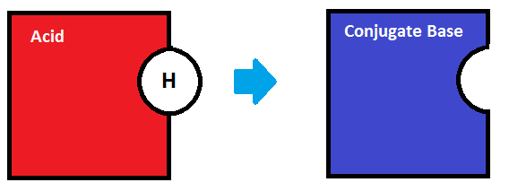
An acid is an acid because it loses a proton. Can the resulting ion gain the proton back? Yes, the proton can be gained back. The resulting anion is called the conjugate base of the ion.
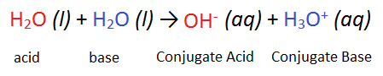
Properties of Acids and Bases
- Acids
  - Taste Sour
  - Conduct electricity
    - “Electrolytes” are ions in a solution that conduct electricity
  - Corrode Metals
    - This is a single replacement reaction (See Ch. 19)
    - Hydrogen gas is formed
  - Reacts with carbonates to form CO₂
    - Reaction can produce violent bubbling called effervescence
- Bases
  - Taste Bitter
  - Feel slippery
  - Can emulsify fats and organics
    - This property explains why bases are often used as cleaning solution
Salts
Definition of a Salt
- Definition
  - A salt consists of a positive base ion and a negative acid ion
  - These cations and anions remain in the solution until the water evaporates; the solid salt precipitate can be seen
  - Neutralization results from the combination of the hydronium ions (formed from protons given off by the acid) and hydroxide ions (released by the base)
  - This combination produces two water molecules

Neutralization
- Process
  - Acids and Bases can cancel out each other’s ions
  - The hydronium and hydroxide ions combine to form water, so the solution is neutral
  - This is a double-replacement reaction (See Ch. 19)
  - Water and table salt, dissolved into ions, are the products
  - If we use other acids and bases, water is still produced, but the salt is different
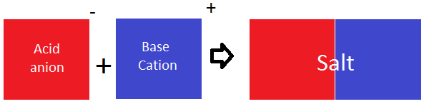
- Using Neutralization Reactions
  - Antacid tablets contain a base to help neutralize excess stomach acid and thus reduce indigestion
Acidity and Alkalinity
Acid Strength
- Classification
  - Acids are classified as strong or weak by their degree of ionization
  - Strong acids lose their hydrogen ions easily and completely
  - HCl (Hydrochloric Acid) is a strong acid because 100% of its ions are given off
  - H₂SO₄ s a strong acid because 100% of its first hydrogen ions are given off
    - The remaining ions do not completely ionize
  - H₃PO₄ is not a strong acid because not all of its first hydrogen ions are given off
Base Strength
- Classification
  - Strong bases ionize completely; weak bases do not
  - A strong acid will always have a weak conjugate base
pH Scale
- Measuring Acidity and Alkalinity of a Solution
  - To measure the acidity and/or alkalinity, measure the concentration of the hydronium ions
  - This measurement is related to the number called the pH number
  - pH- “Power of Hydrogen”
- Scale Division
  - The Scale ranges from 0-14
  - A pH of 7 means the solution is neutral
    - The concentration of the hydronium and hydroxide ions are equal
  - A pH from 0-7 means the solution is acidic
    - There is a greater concentration of hydroxide ions
  - A pH from 7-14 means the solution is alkaline
    - There is a greater concentration of hydronium ions
  - Two solution with pH’s of 6 and 8 will neutralize each other
    - If two solution’ pH’s are the same distance from 7, they will neutralize each other
  - Formula- pH= -log [H₃o⁺]
- pH Indicators
  - A substance that changes color when pH changes
  - (Blue) Litmus turns red in acidic solutions and blue in alkaline solutions
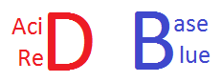
  - Red cabbage leaves have pigments which make them a good indicator
  - Certain Indicators work well with certain substances
  - pH meters are electronic instruments used to provide a more accurate measurement than indicators
  - A probe containing a sensor responds to hydronium ions by producing a current

Test Info
Date: 12/12/12
Room: 208
Instructor: Mr. Jones
Time: 9:15- 10:00

