Physical Science Chapter 7-
Work and Simple Machines
Work and Mechanical Advantage
Mechanical Work
- Basics
  - The exchange of energy for some change in a physical system
  - A scalar quantity
  - Symbolized by W and measured in joules
  - Three Conditions for work to occur
    - A force must be applied
    - The object must move
    - The object in the direction of motion
  - When work is done on a system, it gains energy
  - Work= force x distance
W=Fd
Power
- Basics
  - Power is the rate of work. It is how fast the energy is released.
  - The unit of power is the watt
  - Power= work/time
Power= force x distance/ time
  - A machine doing more work in the same amount of time or the same work in less time than another machine has more power.
Simple Machines
- Basics
  - Simple Machines can help do work faster and easier
  - They help reduce the toll of work caused by the curse on fallen man
  - They do not change the amount of work necessary to do the job
- Types
  - Levers
  - Wheels and axels
  - Inclined planes
Efficiency
- Basics
  - Theoretically, a machine can be no more than 100% efficient
  - Practically, a machine must be less that 100% efficient
  - Efficiency is expressed as a percentage using the formula
W_{out}/W_{in} x100
Distance Principle

- Basics
  - Machines make work easier by reducing the amount of force needed to do the work
  - W=Fd
    - If the W stays the same and F decreases, d must increase
    - So the force is reduced by exerting that force over a longer distance
Mechanical Advantage
- Basics
  - The reduction of force is called the Mechanical Advantage (MA)
  - MA has no unit
- Types
  - Actual Mechanical Advantage (AMA)
    - To calculate the AMA, use:
weight = resistance = F_{r}
force effort F_{e}
    - The AMA shows the helpfulness or usefulness of a machine
    - The AMA includes the effects of friction
    - If we assume that there is no friction (often) the we are computing the IMA
    - The AMA will always be less that the IMA
  - Ideal Mechanical Advantage (IMA)
Levers and the Law of Moments
Lever
- Definition and Terms
  - A rigid bar that turns around a point
  - The fixed point is called the pivot point
  - A common lever is a see-saw
  - If the weights and positions of people on a seesaw are balanced, the see-saw is said to be in a state of rotational equilibrium
  - Any time a force acts perpendicularly on a rotating lever, it produces a quantity called a moment or torque
The Law of Moments
- Formula
  - The formula for the law of moments is
w₁l₁=w₂l₂
    - w= weight in N
    - l= Distance from the fulcrum (m)
- Terms and Application
  - The l can also be called the torque arm or moment arm
  - When a see-saw is balanced, the torques are equal
First-Class Levers
- Definition
  - In first-class levers, the fulcrum is in the middle
  - The push (effort) is at one end
  - The weight (resistance) is at the other
  - Ex: see-saw
- Terms
  - The side on which the push occurs is called the effort arm
  - The side on which the weight is found is called the resistance arm
  - The Law of Moments allows us to solve problems involving levers
  - First-class levers have an IMA of less than one, one, or greater than one depending on the lengths of the moment arms
  - If they are unequal, one side has an MA>1 and the other side has and MA<1
  - MA= Resistance
Effort
Second-Class Levers
- Definition
  - A second-class lever has the resistance in the middle
  - Ex: Door hinge, wheelbarrow
  - The MA of second-class levers will always be greater than one because the effort arm is longer than the resistance arm
  - MA= Effort
Resistance
  - MA>1
  - Second-class levers allow for a smaller effort by exerting that force over a longer distance
Third-Class Levers
- Definition
  - A third-class lever has an effort applied between the fulcrum and the resistance
  - Because this makes the effort arm shorter, the MA is always less than one
  - A MA that is less than one multiplies the amount of effort motion
  - A MA that is greater than one multiplies the effort force
  - MA= Effort
Resistance
  - MA<1
Wheels, Gears, & Pulleys
- Introduction
  - In many cases, a lever’s motion is restricted
  - Other simple machines do not have this limitation
Wheel and Axle
- Definition and Terms
  - A rotating object where the force is applied at some distance from the axis
  - This turning force creates a moment or torque
  - The effort arm is the distance from the center to the applied force
  - The resistance arm is the distance from the center to the resistance
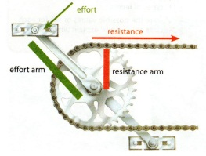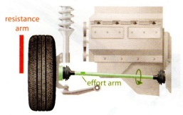
Effort Resistance ↑
The effort arm is from the center of the axle to the outside
  - Any device with a handle that turns in a circular direction is most likely a wheel and axle
  - IMA= Effort
Resistance
Gears
- Definition and Terms
  - Gears are wheel and axle combinations with notches or teeth around the circumference
  - When two gears touch, they always turn in opposite directions
  - The IMA of two gears can be determined by the ratio of the number of teeth with the following formula:
IMA= Resistance Gear Teeth
Effort Gear Teeth
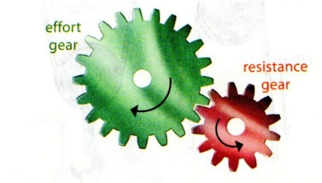 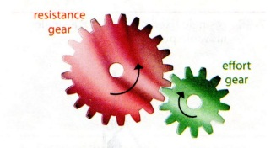
Increases Speed Decreases Speed
  - Gears can also change the direction of motion
  - Gears can be combined into systems that can be very complex
Pulleys
- Definition and Terms
  - A pulley is a wheel with a groove containing a rope or cable
  - The effort arm length and the resistance arm length are the same distance from the center to the outside of the pulley
- Pulley Types
  - Single fixed
    - A single fixed pulley has an IMA of 1
    - Why do we use it then?
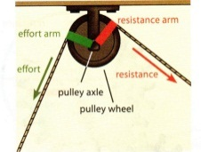
    - We use it because you are able to use your weight to lift the object
  - Single Movable
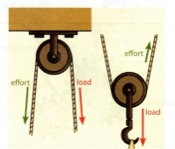
    - A single movable pulley has an IMA of 2
    - The rope is supported at both ends, so only half of the weight is at each end
  - Block and Tackle
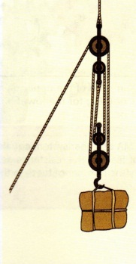
    - A group of pulleys working together is called a pulley gang or block and tackle

    - To find the IMA of a block and tackle, count the number of supporting ropes
    - DO NOT count the section of rope which supplies the effort
    - Block and tackle greatly increase the MA
Inclined planes, wedges, and screws
Inclined planes
- Definition and Terms
  - An inclined plane or ramp is a tilted surface which allows resistance to be lifted with less effort
  - The reduction in effort is accompanied by an increase in force
  - The AMA of an inclined plane is resistance (weight) divided by the effort
    - AMA = resistance
effort
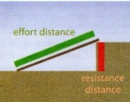
  - The IMA of an inclined plane is the length of the incline divided by the height of the incline
    - IMA = length
height
Wedge
- Definition
  - A wedge is normally shaped like two inclined planes back-to-back
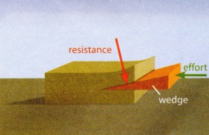
  - It is used to split an object and it is forced into the object
Screw
- Definition and Terms
  - A screw is an inclined plane wrapped around a central shaft in a spiral shape
  - The ridges on a screw shaft are called threads
  - The distance between the threads is called the pitch
  - The lower the pitch, the higher the MA
Test Info
Date: 2/18/13
Room: 208
Instructor: Mr. Jones
Time: 9:15- 10:00

